**Project**

Create a website that deal with online purchase of groceries.

**Angaadi/GroKart** is a Simple basic Grocery Store. The grocery store include functions like

1.Home Page

2.User Login/Logout

3.New user Registration

4.Admin login

5.User Edit/Removal(Admin functionality)

6.User Edit/Removal(Admin Functionality)

7.Add grocery to cart/wishlist

**Design**

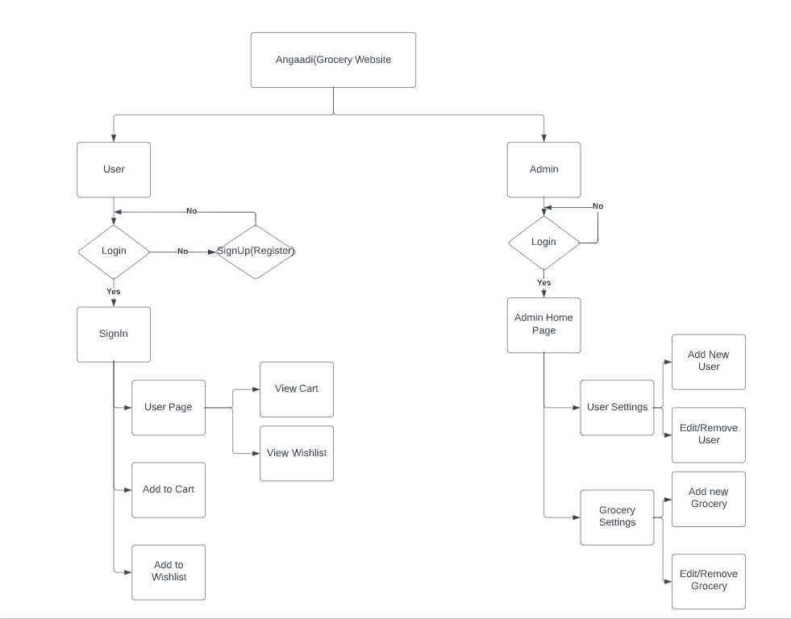

**Grocery Website Front End - Angular Application**

1.Home Page:

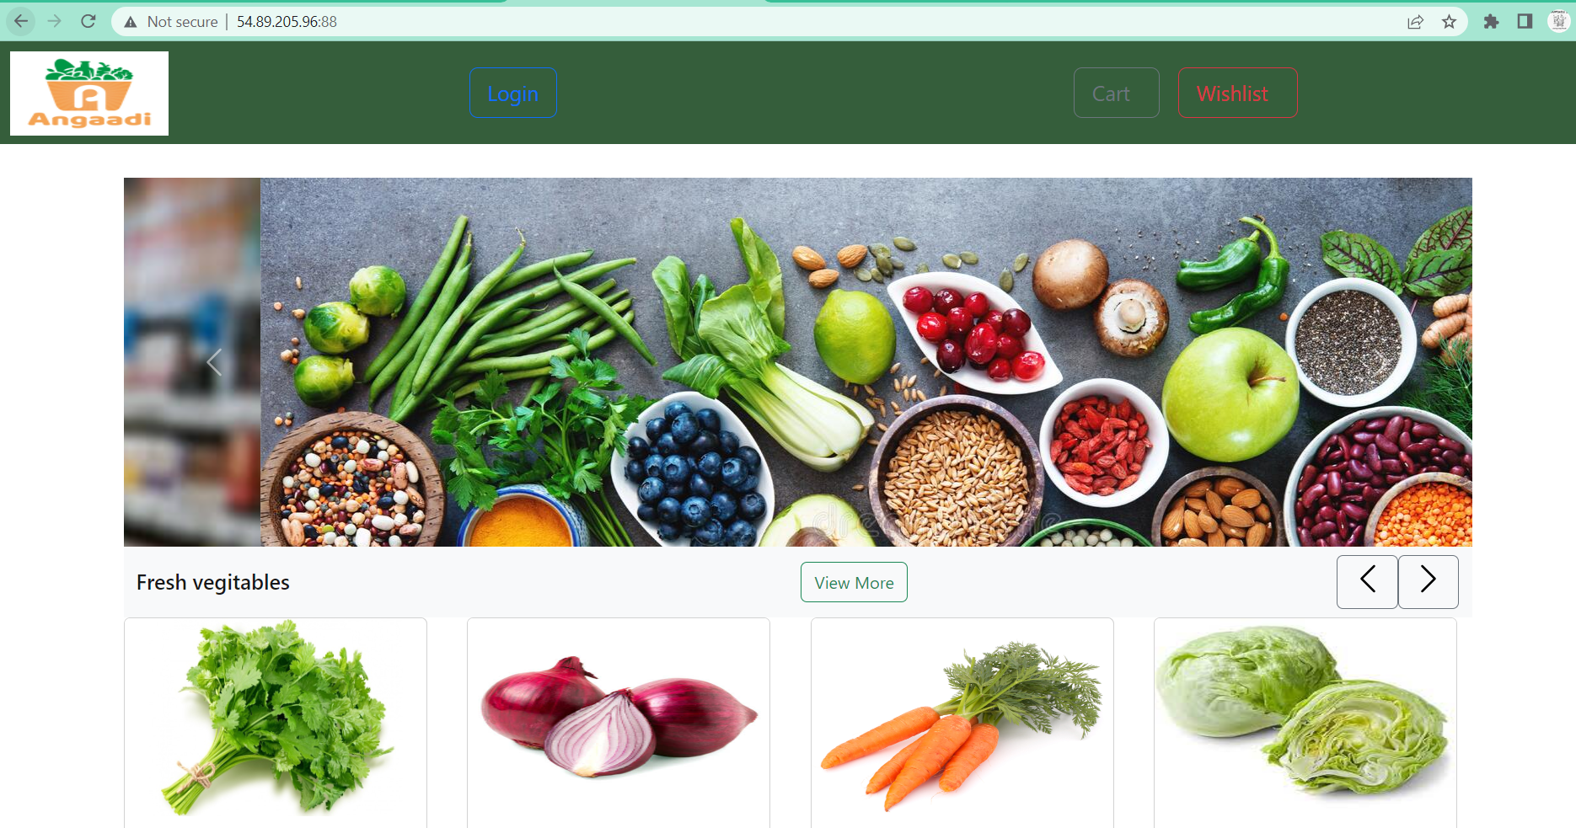

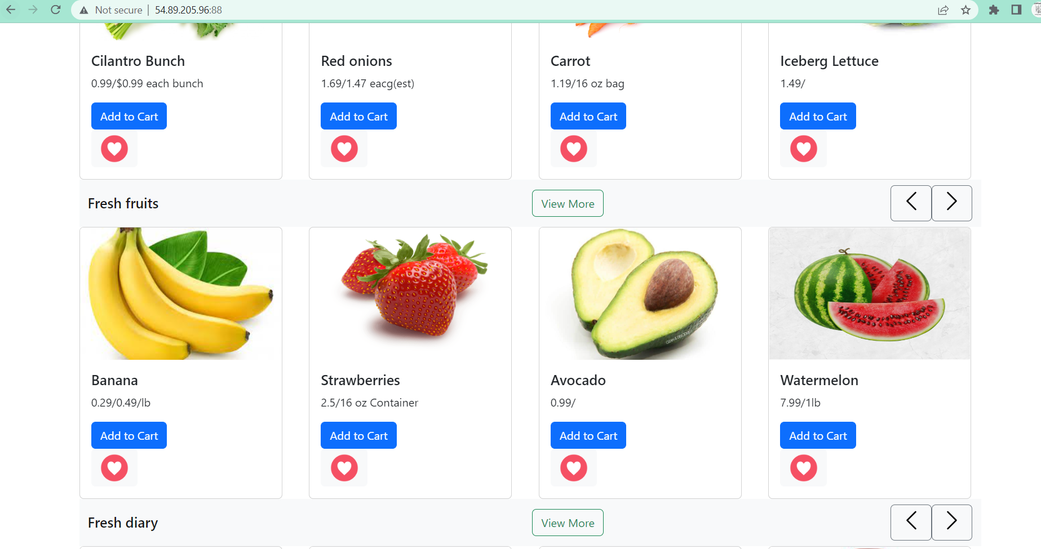

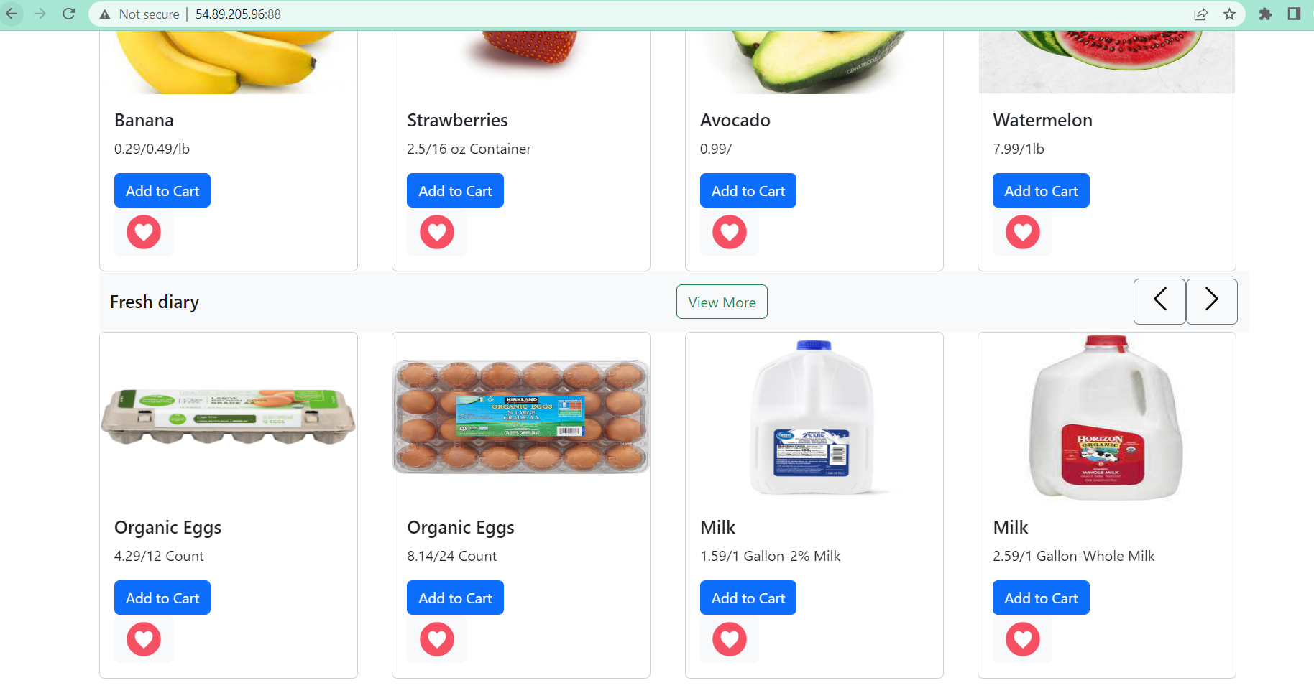

* Home Page Containes a navbar, Navbar includes logo, Login button, User Cart and User Wishlist button
* Homepage have 3 different section to display Vegetable, Fruits and Diary items available in the Online store
* Login Button: Once the user click on the login button, the page will navigate to SignIn Page
* Cart: Once the user logins page , the user can add vegetables in to cart ,Once the user adds the vegetables the added vegetables will be available on the cart page.
* Wishlist : Once the user logins page ,the user can add vegetables in to wishlist ,Once the user adds the vegetables the added vegetables will be available on the wishlist page.
* From the Home page itself user can add groceries into cart or wishlist.
* While adding the groceries in the cart, user can select the quantity as well.
* The user can add groceries into the cart or wishlist only by SignIn in the grocery website.

2.GroceryHome Page:

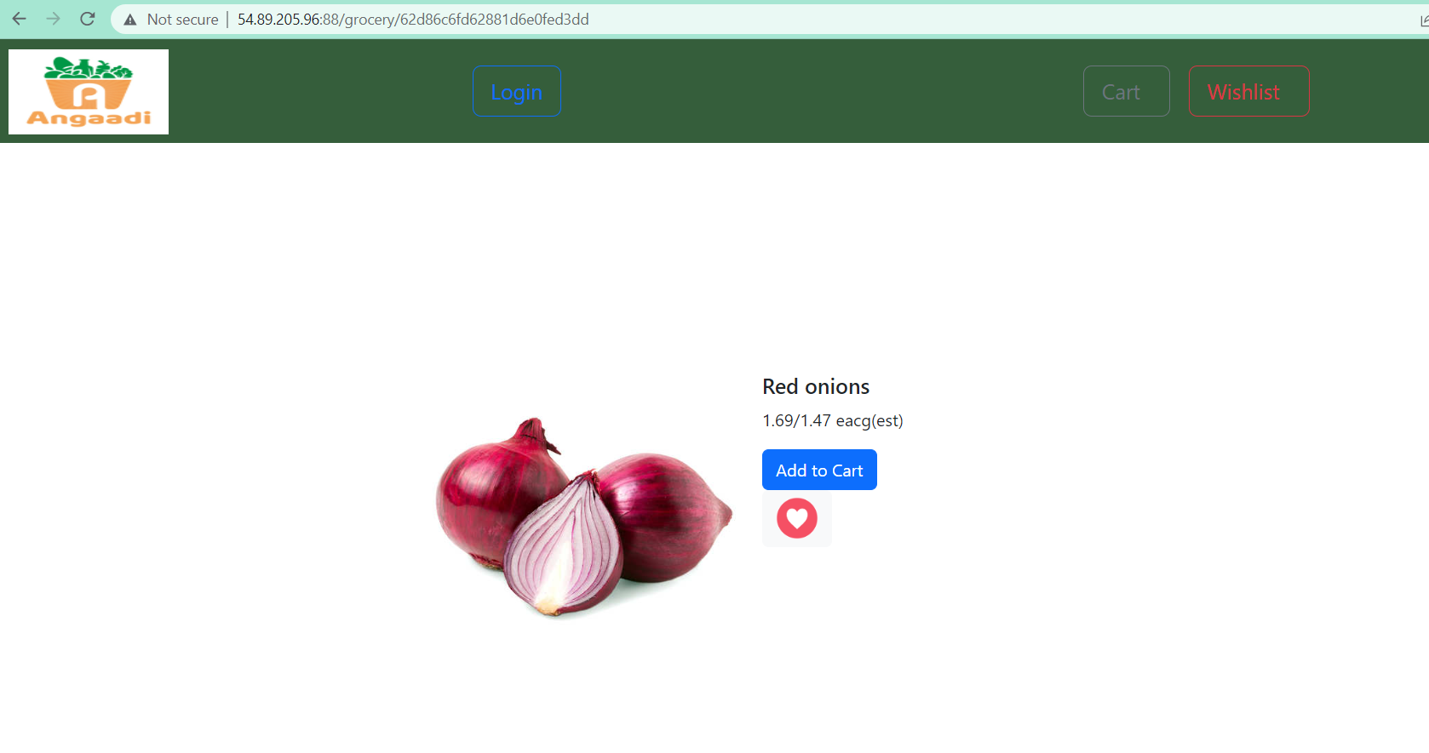

* Grocery Home page will be display once the user click on the image of each grocery page
* Grocery Page have Add to cart, Add to Wish list button
* Once the user click on the Add to Cart, the button will turn into increment button to select the quantity of the grocery.
* Once the user click on the Add to Wishlist, the grocery will add into Wishlist and remove from Wishlist button will get displayed.

3.Login Page

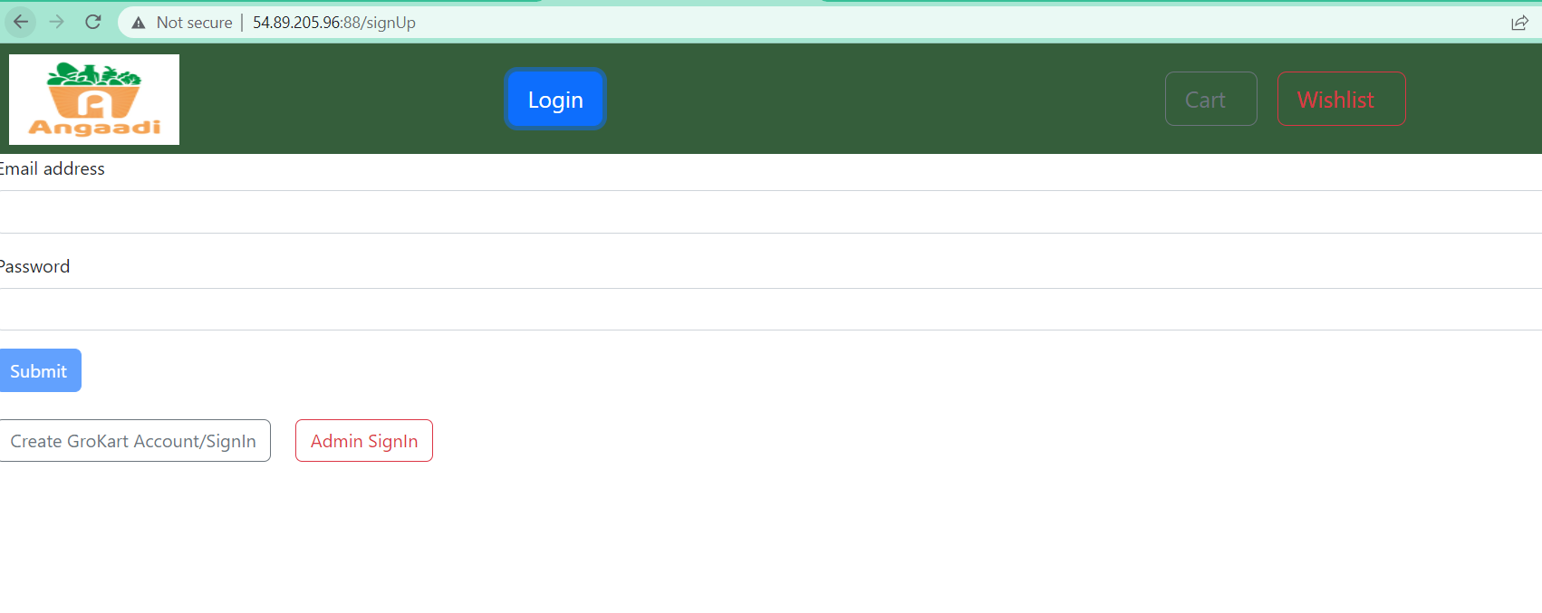

* Once the user click on login button, the page will navigate to Sign up page

4.Sign Up Page



* Sign up page contains 2 text boxes for email and password. the user should provide the registered email and password.
* The page also contains new user registration and Admin Sign in options

5.SignIn page

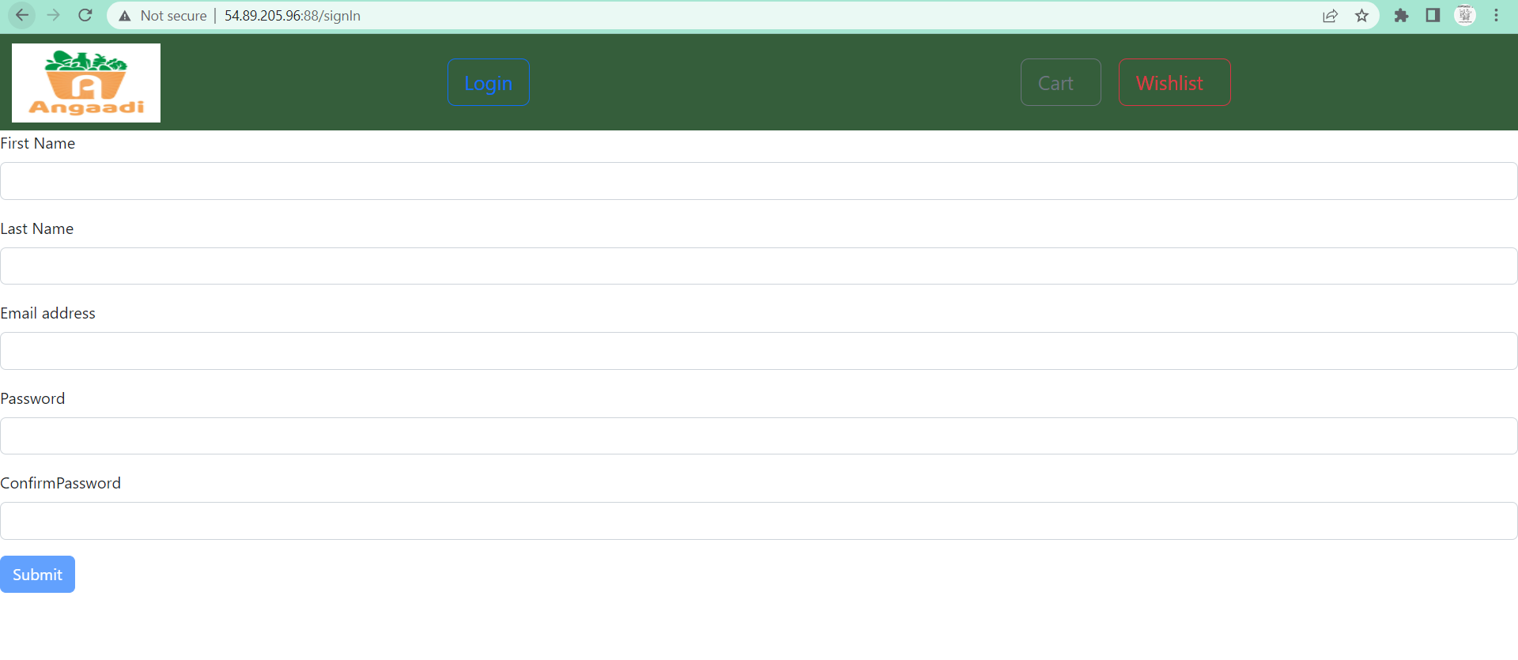

* SignIn page contains textboxes for Firstname, Lastname,Email,Password and confirm password.
* Each textboxes contains the validation.
* User should give values for all textboxes and click submit button.Then only user will be able to register the new User.

6.Admin Page

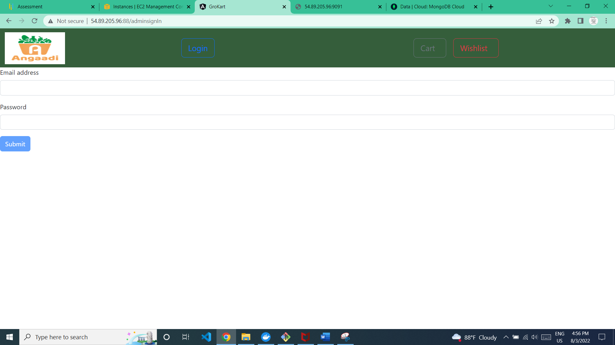

* Admin Sign up page contains 2 text boxes for email and password. the user should provide the registered email and password.
* The admin user can only register through the database.
* Once the Admin logins the admin can see two options

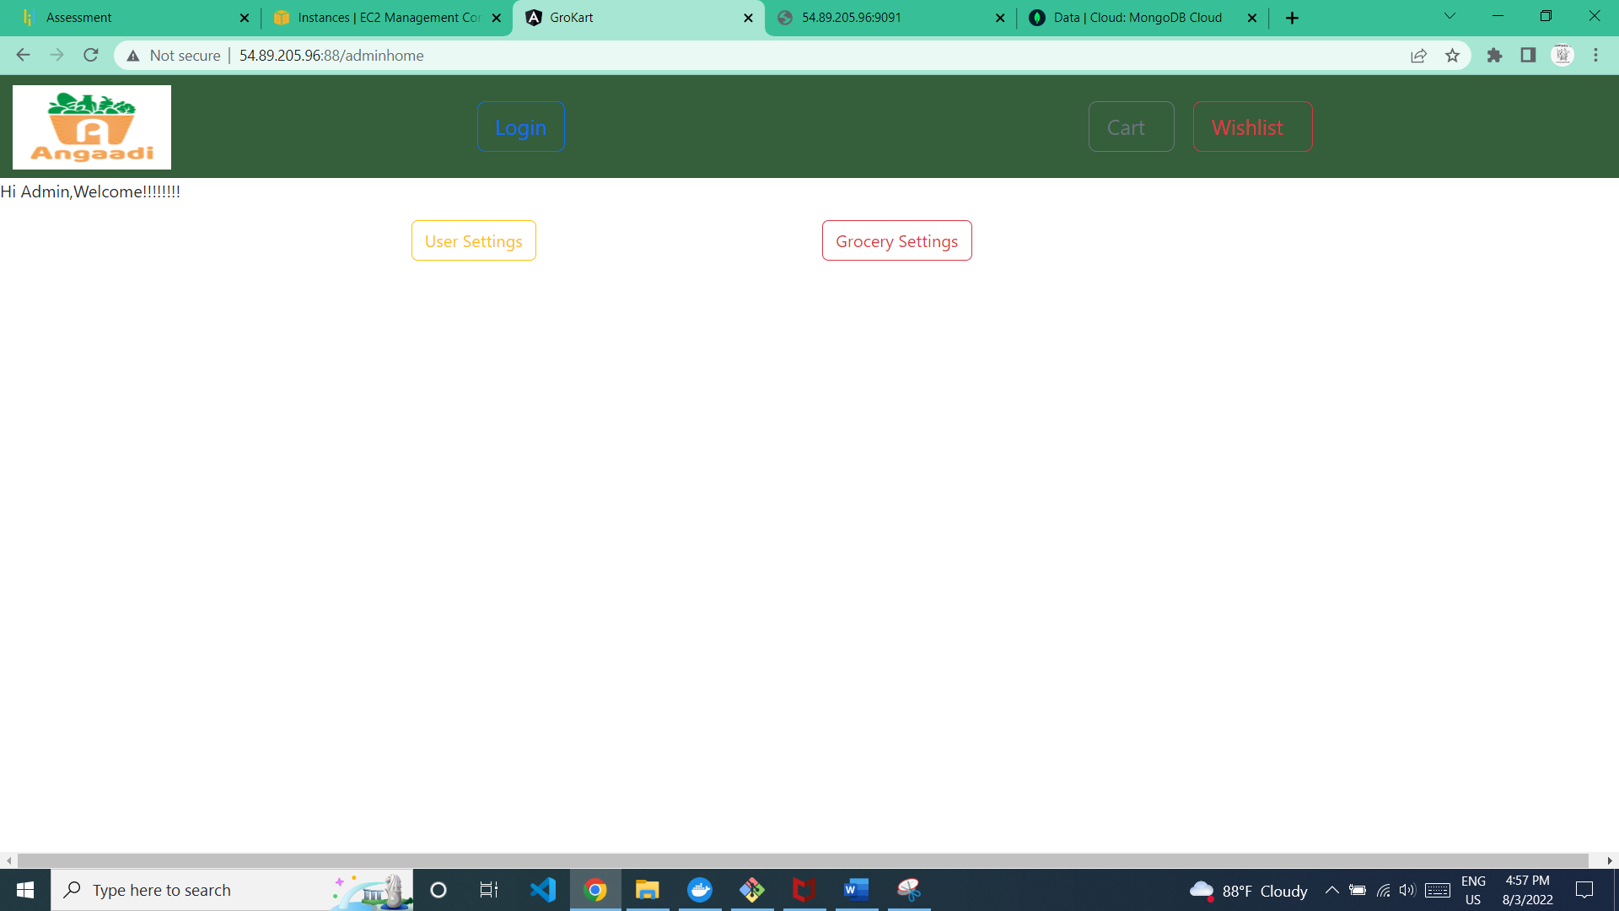

* User Settings

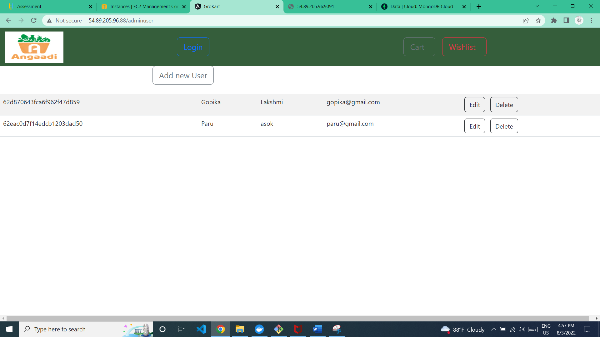

1. Add new user: Admin can add new users
2. Admin can edit/delete each users

* Grocery Settings
* 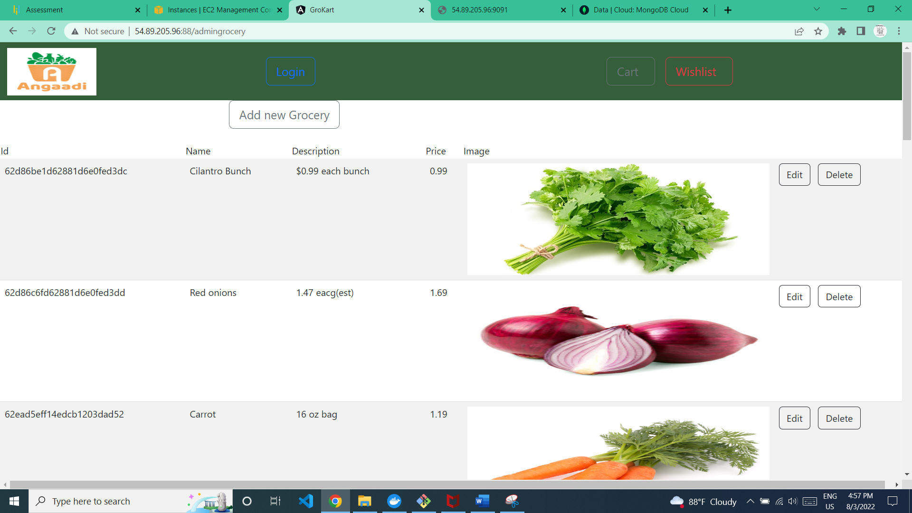

1. Add new Grocery: Admin can add new grocery.
2. Admin can edit/delete each grocery.

7.Cart Page

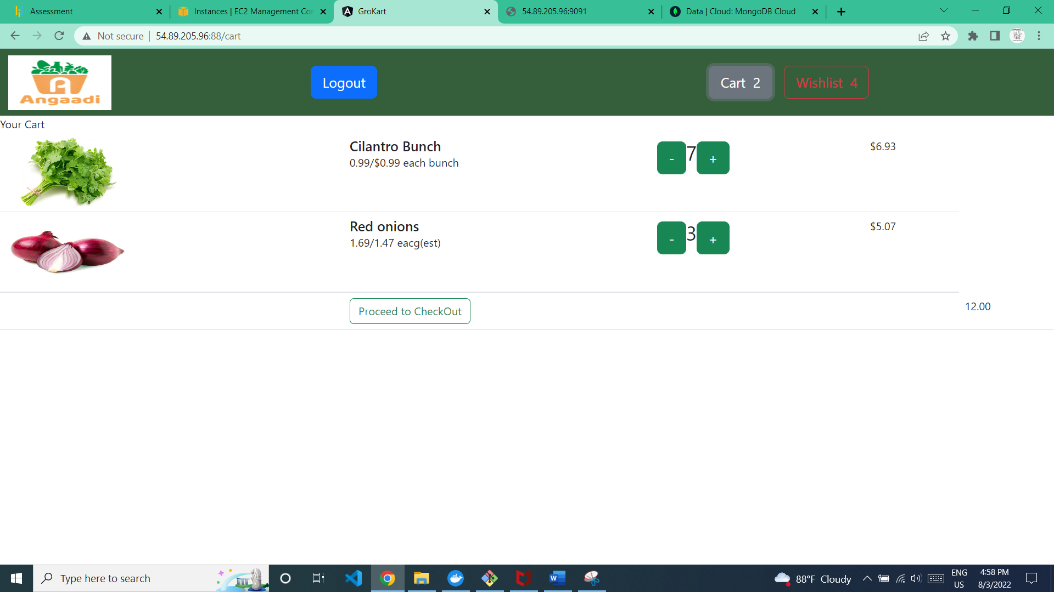

* The added groceries with quantity will be displayed in the cart.
* The user can also decrement or increment quantity of each item
* The Checkout price also will be displayed.

8.Wishlist Page

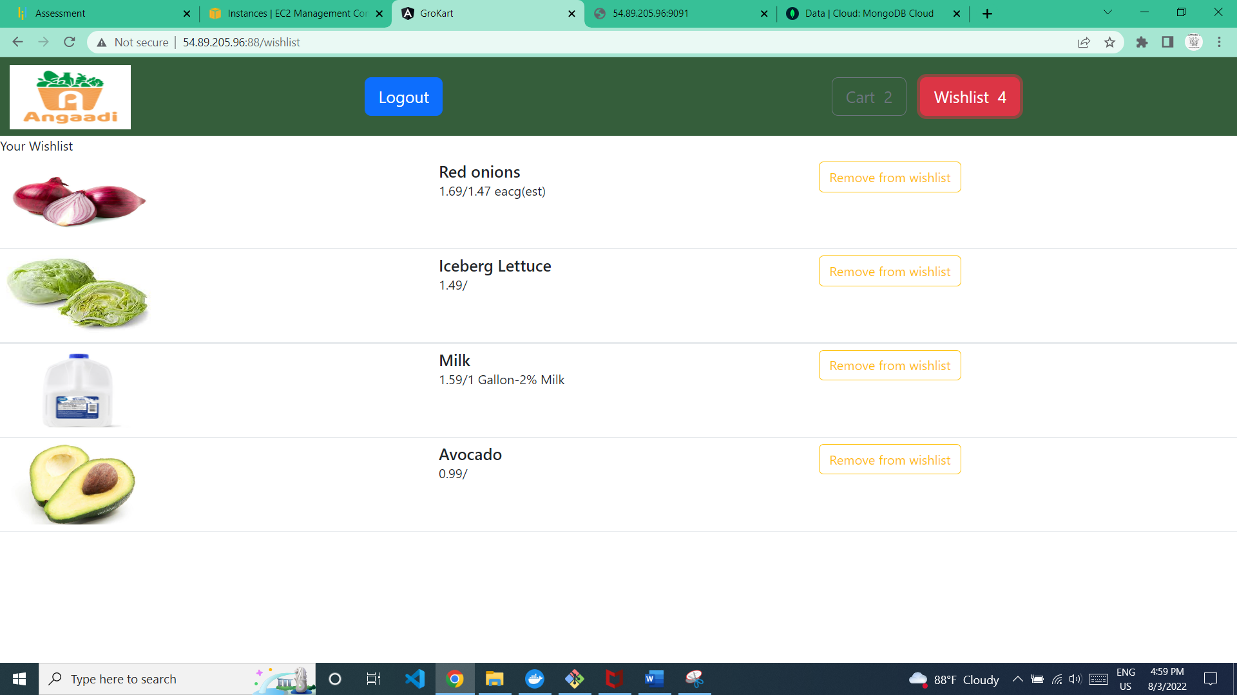

* The added groceries will be displayed in the Wishlist.
* The user can also remove the grocery from the Wishlist
* Ran ng build,so the project files are created inside dist folder
* Created a Docker file

**Grocery Website BackEnd End – Node,Express and mongo Application**

1. app.js

* Added express, cors and mongo modules
* Assigned 9090 port
* Used controller,repository and dbconfig to save the data in mongo db.

2.ChatController,ChatRepostory,DBConfig

* Dbconfig🡪config.js is used to connect to capstone database.
* ShopRepository🡪used to update, Insert ,delete and find User ,Grocery ,cart and Wishlist table in Capstone database.
  + Grocery Functions:

1. findAllproducts:Find all groceries from grocery table in db.
2. Findproduct:Find a grocery from grocery table based on the id provided.
   * User Functions
3. storeUser: Add new user details into User Table
4. userValidation: Validate whether the user is registered or not
   * Cart Function
5. AddtoCart:Adding grocery id,quantity and user id to cart table
6. updateQuantityCart:While incrementing/decrementing the quantity each time,this function is used to update the quantity based on the cartid
7. findCartByUseriD:Find the cart items based on the userid
   * Wishlist Function
8. AddToWishlist:Adding the the wishlist grocerid,userid into the wishlist table
9. findwishlistByUserIdgroId: Finding the wishlist of a user by userid and grocery id.
10. findWishlistByUserId: Finding the wishlist of a user by userid
11. removefromwishlist:Removing the wishlist grocery item from wishlist table
    * Admin
12. findAllUsers:Finding all the users from user table.
13. Deleteuser:deleting user from user table
14. Findauser:find a user based on the userid
15. updateUser:updating the userdetails based on the userid from user table.
16. Deletegro:Deleting grocery from grocery table
17. Addnewgro:Adding new grocery into grocery table.
18. updateGrocery:Updating the existing grocery

* ShopController🡪Will pass the JSON converted data to Shop Repository from Router.
* ShopRouter🡪 The router will route each request to Shop controller
* Created a Docker file

**Docker Image**

Published frontend and backend docker image in Docker hub

Image name: gopikalakshmia/**my-capfrontangular1-image,gopikalakshmia/my-capbackend-image**

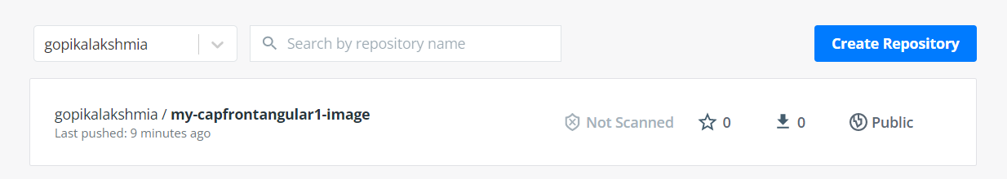

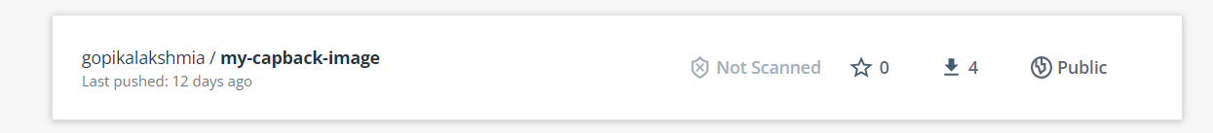

**EC2 Instance**

Deployed the angular application in EC2 instance

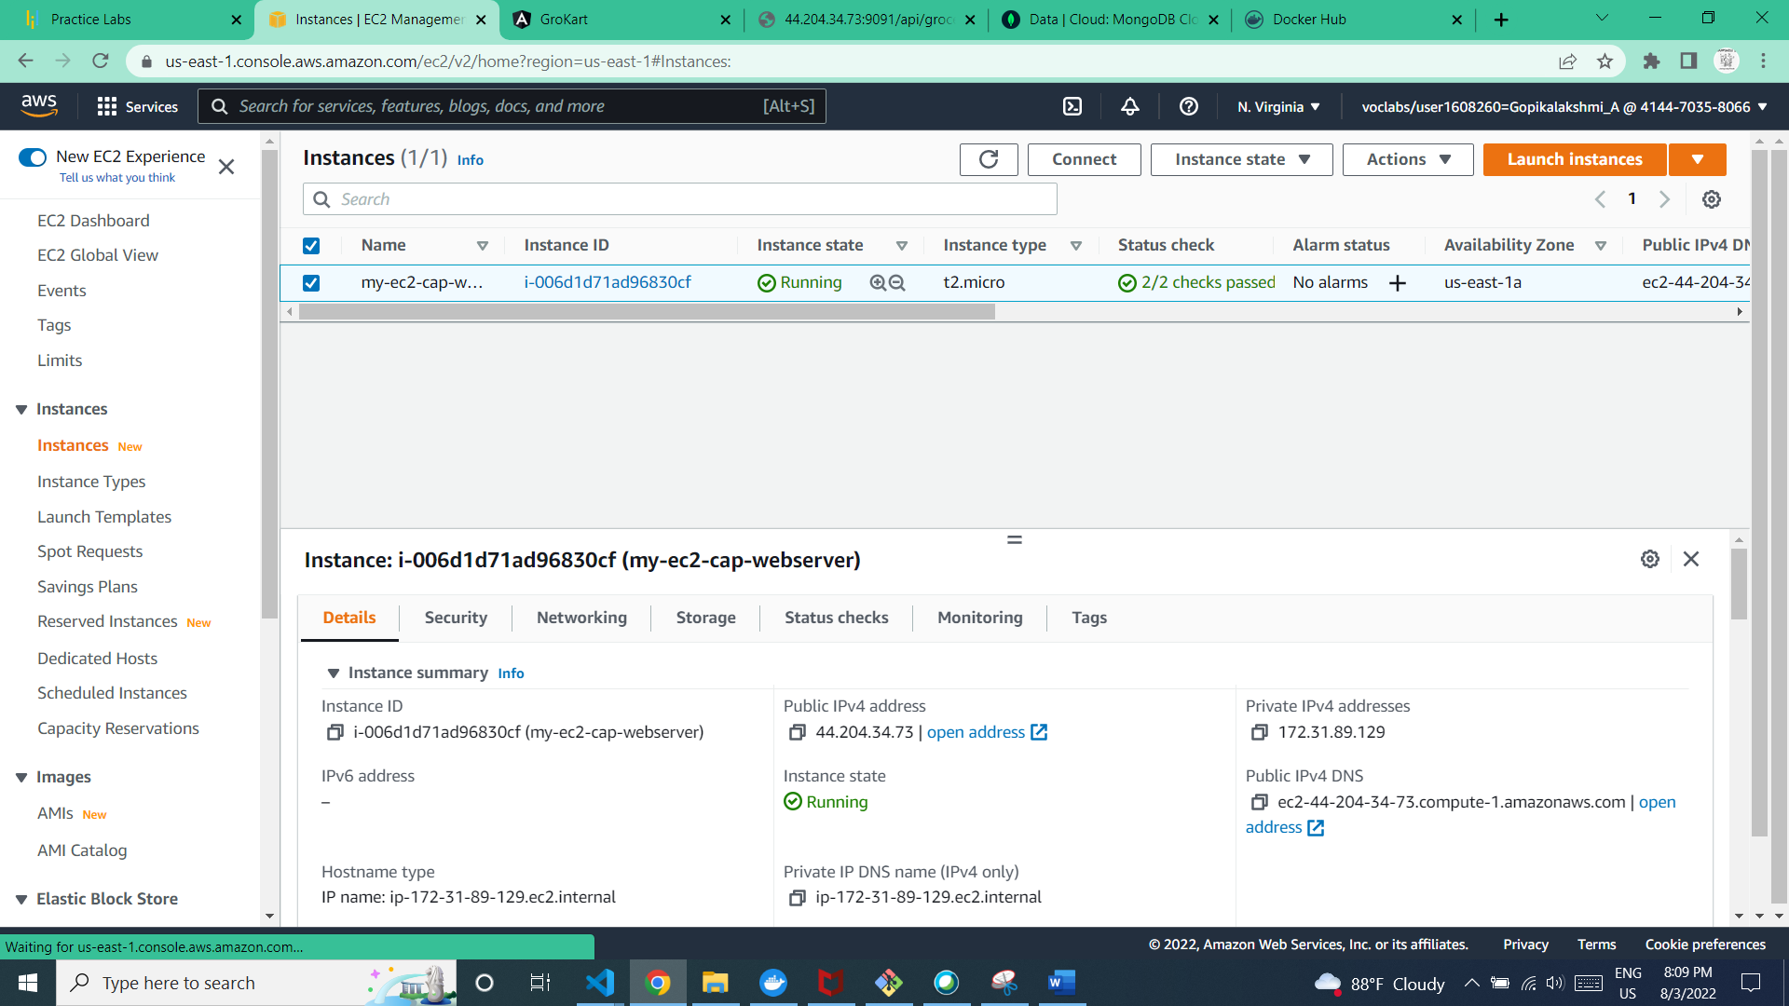

**Frontendport:88(http://44.204.34.73:90/)**

**Backendport:9091(http://44.204.34.73:9091/**